9 European Maxibasketball Championship in Novi Sad

9 European Maxibasketball Championship was held from 24.06. to 03.07.2016 in Novi Sad, Serbia. Novi Sad is the capital of northern Serbian province of Vojvodina and Serbia’s second largest city after Belgrade. The city also is one of the largest economic, cultural and sports centres in Serbia and former Yugoslavia. Novi Sad is an exceptional host city for many sporting events. The city has a large and very basketball oriented community with a lot of famous athletes and sport clubs. Novi Sad shares the glory of great Serbian basketball history. Serbian people with their welcome and hospitality created in Novi Sad outstanding and memorable event. The Championship began with parade of teams-participants on city streets. Citizens loudly welcomed delegations. After that teams’ members and fans took part in the spectacular opening ceremony. Guests savoured the festive atmosphere of the tournament.
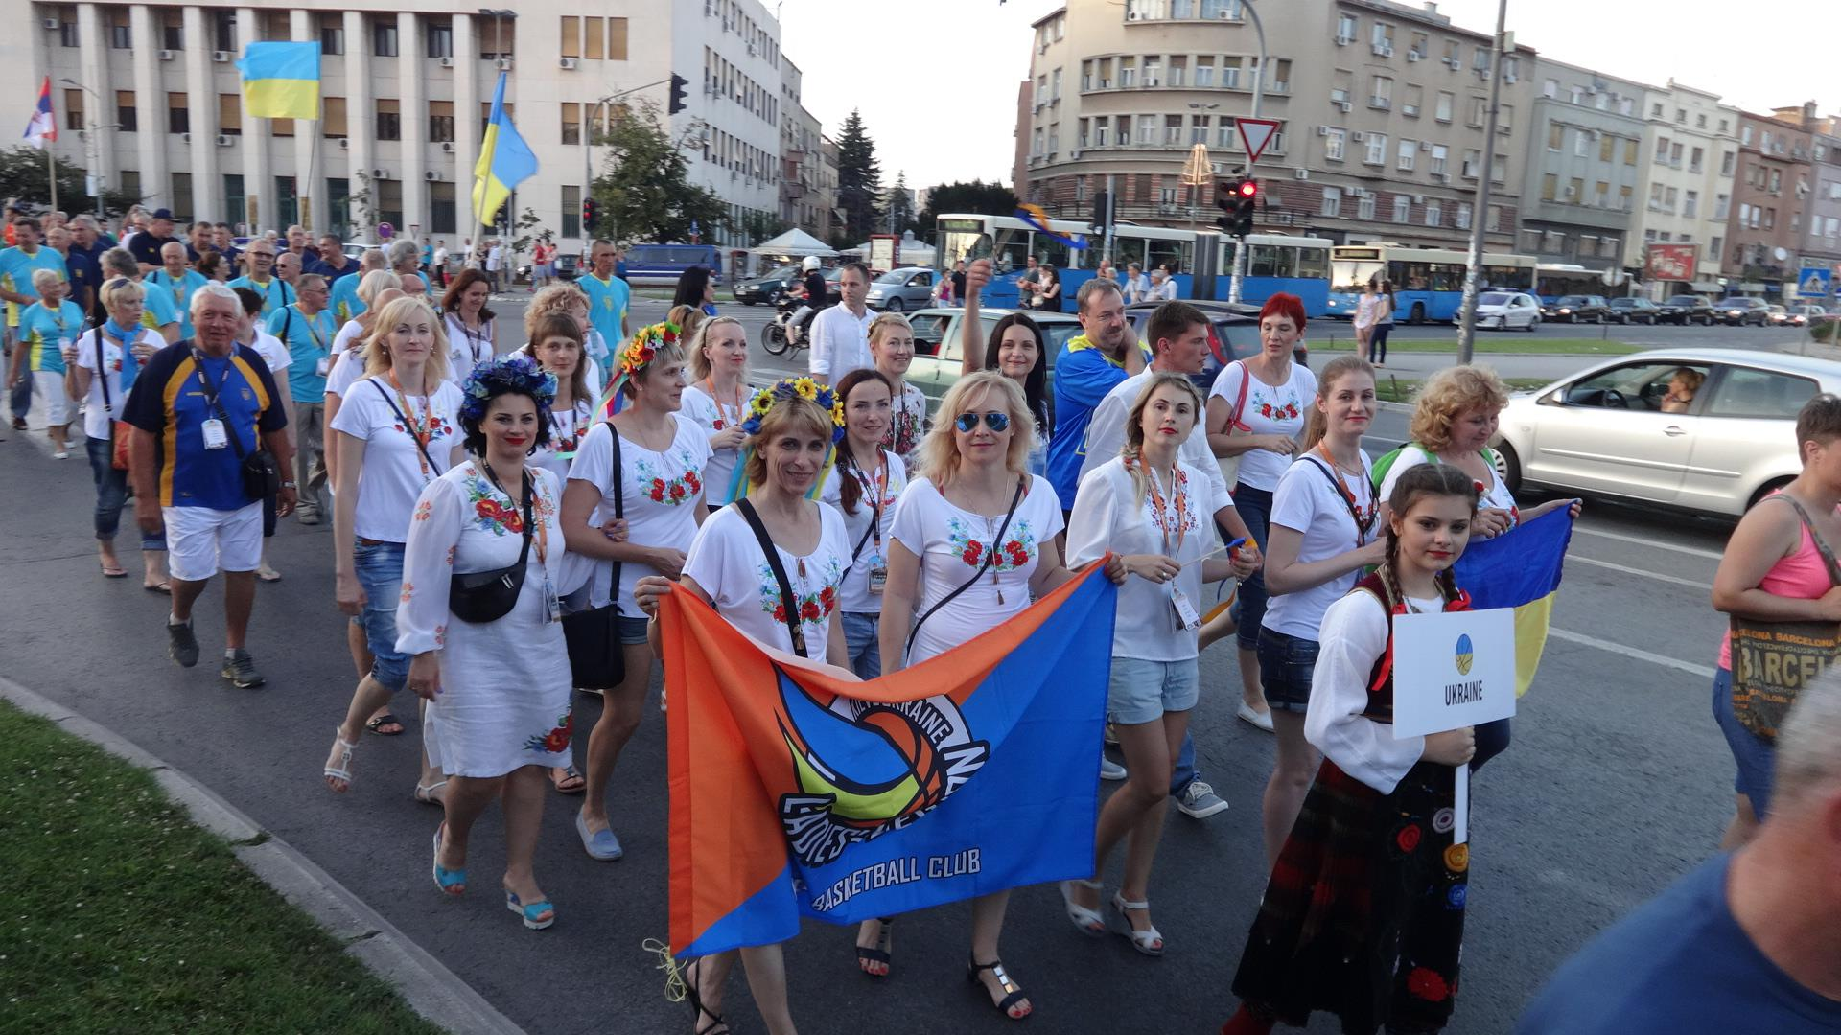
Organizers provided excellent conditions for participants. Games were played in the world-class Sports Hall “SPENS” (5 courts) and University Centre (2 courts). 120 teams from more than 20 countries took part in the Championship. Ukraine was presented by two female teams: “Ladies’ Legion” in F30+ age category and “Ladies’ Legion” in F45+ age category. Two Ukrainian men’s teams “Veteran Basket Ukraine” in M50+ age category and “AMIGO-Nikolayev” in M60+ age category contested in the Championship.
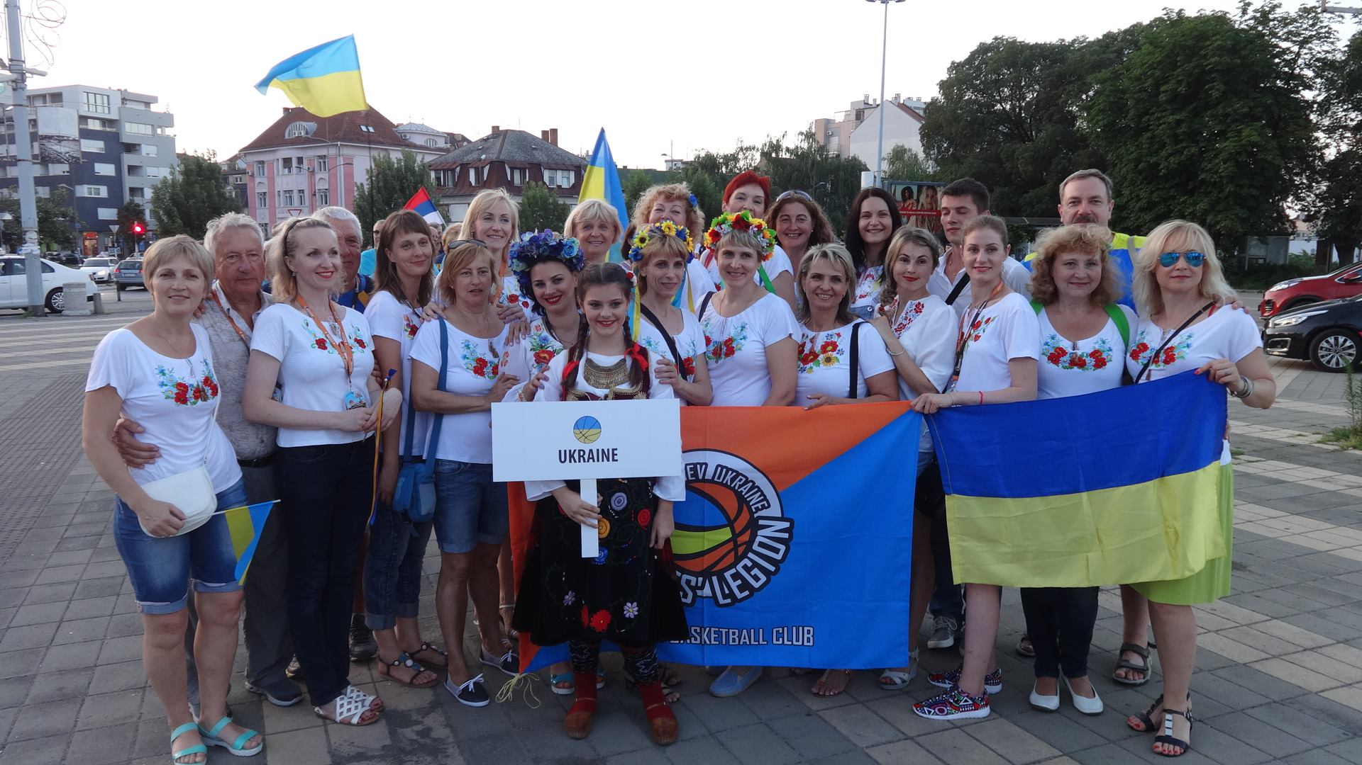
At the preparation phase for the European Maxibasketball Championship2016 many coaches and players realizednew tendency towards tournament’s games with very high physical and tactical level. Games at Novi Sad’s courts confirmed these predictions. This Championship was more competitive with a hard-fought matches which needed a great endurance. Players were much better prepared for the European Championship 2016 compared to the past tournament. Veterans meticulously prepared for the Championship in full accordance with training and fitness programmes. Spectators had so much respect for what veterans did physically at their age.
But Ukrainian male team “VeteranBasket” didn’t accept the new situation and find solutions corresponding with a new Maxibasketball reality. Last year at FIMBA World Championship in Orlando “VeteranBasket” M50+ team secured easy victory against Italian team with twenty-point advantage. This year at FIMBA European Championship Ukrainian team with their stellar line-up (OleksandrVolkov, YuriyKosenko, Igor Didenko, AndriyBerezhinskiy,…) hoped to repeat the last year’s success in their first game with “Italy Ponzoni” team. But Italian team had prepared for this game in the best possible way and“VeteranBasket” teamwas pounded by “Italy Ponzoni” 81-52. It was a devastating blow to Ukrainian veterans but Italy deserved the win, there was no doubt. “VeteranBasket” team’s players with big efforts restored their psychological balance and at least saved face in the match for the 8th place outscoring Austria 66-51.
In M60+ division Ukraine was presented by “AMIGO-Nikolayev” team. More than 10 years this team competed very successfully in European and World Championships, conquering cups and medals from bronze to gold. “AMIGO-Nikolayev M60+” team consisted from the players of Nikolayev Maxibasketball club “AMIGO” with invited BorisIamkovoy from Donetsk. Boris is avery talented player and a great friend of Nikolayev’s team.
“AMIGO-Nikolayev 60+” team was created from veterans who had competed in Maxibasketball teams of younger age categories earlier. In this line-up Ukrainian team intended to achieve great success next year in the FIMBA World Championship2017 Italy, MontecatiniTerme. In thisEuropean Championship “AMIGO-Nikolayev 60+” team’s players adapted to a new line-up and to a new age category.
In the first game “AMIGO-Nikolayev” competed with “Slovenia-Dekleva” team. Match passed in equal strife with multiple lead changes. Both teams struggled to add points to their wins. Main Ukrainian team’s scorers provided valuable support to their team: VolodymyrGamov-16 points, Borys Iamkovoy-14 points, Oleksandr Shneyder-14 points. But “AMIGO-Nikolayev” team couldn’t restore forcefor win after the long road to Novi Sad City. It was the Slovenian team who made the stronger finish sealing a one-point victory 55-54.
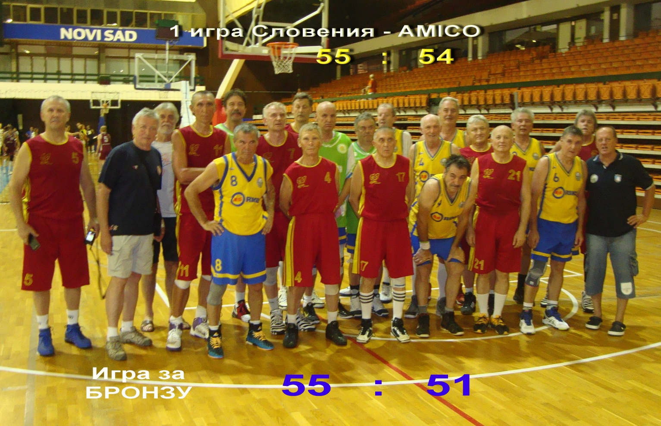
In the next games with Austria and Germany “AMIGO-Nikolayev” team bounced back and showed a lot of fighting spirit overpowering opponents with a big advantage. Ukrainian team overwhelmed Austria 66-33, finished job against Germany 53-27 and went to semi-final. Serbia was the better side in the semifinal, outscoring “AMIGO-Nikolayev” team 62-46, and deservedly entered the final. In the final Serbia beat Estonia 56-44 to conquer the European title.
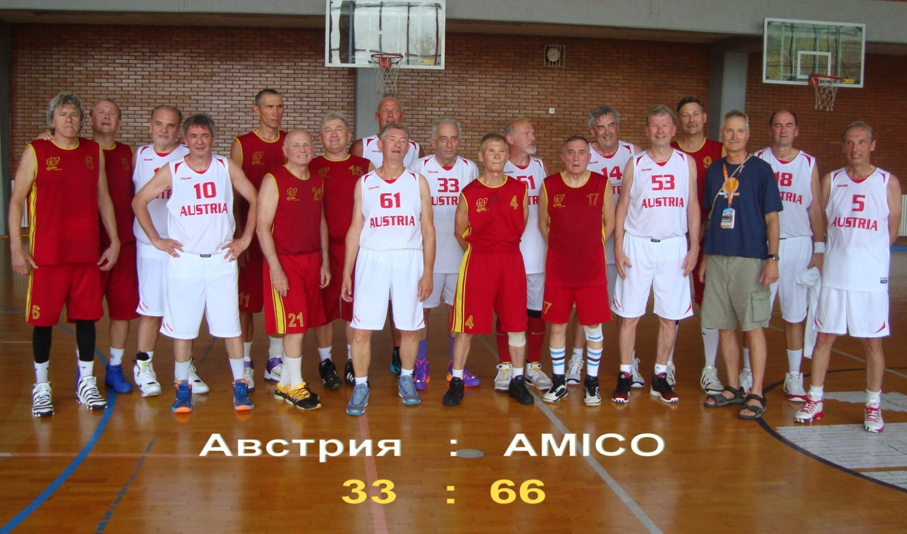

“AMIGO-Nikolayev” and “Slovenia-Dekleva” teams repeatedly met in the 3rd place play-off. It was a tug-of-war game where rivals didn’t play humble and beautiful basketball. They just had to be stronger. In the first half Ukrainian players were very unlucky in their shooting efforts. Slovenians gradually strengthened their position in the game.But the main events took place in the last period. “AMIGO-Nikolayev” went on remarkable 12-0 run and cut the gap to one point. Within 5 minutes OleksandrPetrov and Leonid Sorokin delivered 7 and 5 points respectively. Team’s captain Yuriy Zhukov demonstrated perfect productive passes and strong aggressive defense. Taking into account 15 points in this game Borys Iamkovoy collected a team-high 78 points. The victory was close to “AMIGO-Nikolayev”. But the damage had been done and “Slovenia-Dekleva” team sealed the 55-51 victory and captured third place. “AMIGO-Nikolayev” team received cheering bronze medals.
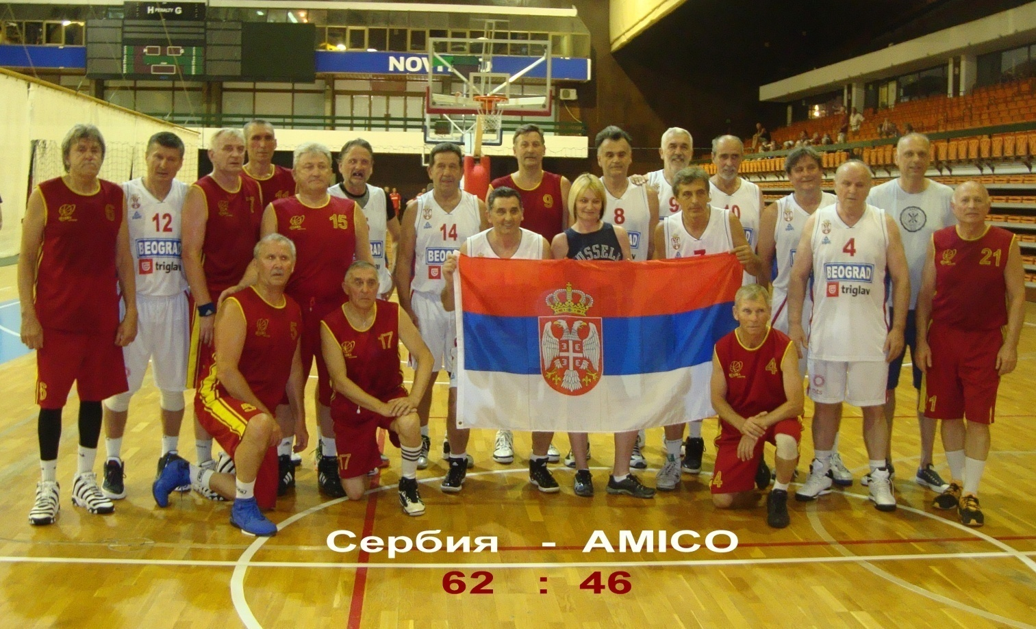

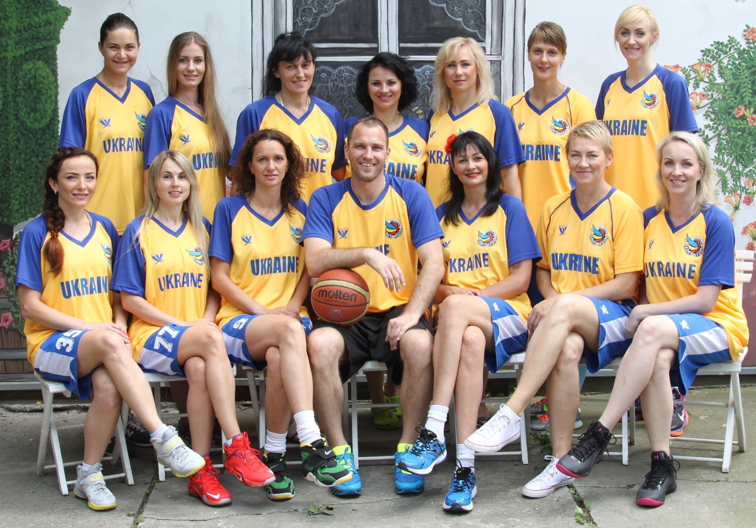

Ukrainian female teams (both from “Ladies’ Legion” Club) acted more successfully at the tournament as what male teams. In the legendary “Ladies’ Legion F30+” team Nikolayev’s Maxibasketballwas presented by Elena Zhukova. Yuriy Zhukov and Elena Zhukova had given a big help in preparation and sponsoring of these teams.
A very experienced “Ladies’ Legion F30+” team planned to win gold medals. After the preliminary matches the team reached the semifinal where Ladies faced aggressive Russian team. It was a war of nerves. Ukrainian players made mistakes and didn’t play their best game, losing the game 42-50. But they emerged stronger from the pain of the loosing match against Russia.
In the game for the third place“Ladies’ Legion F30+” team struggled against old rivals from Lithuania, a real strong side, a team with character, with individual talents. It was a game on a tactically and physically very high levels from both teams. Ukrainians were the better side and deservedly won the match 51-40 and received bronze medals. It was good game, a nice victory.
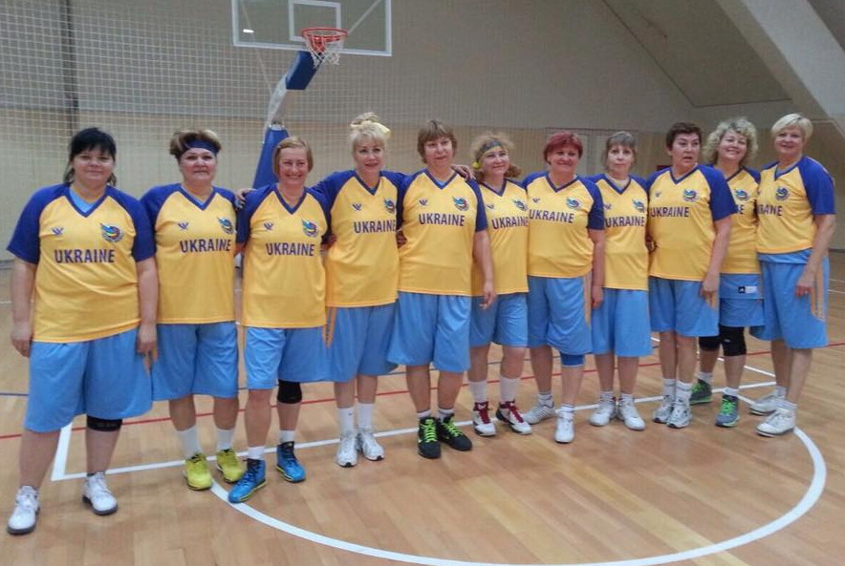
Former Ukrainian female players from different European countries gathered in“Ladies’ Legion F45+” team. They were glad to meet the former girlfriends with whom they played in one team earlier.“Ladies’ Legion F45+” team started strongly at the tournament. Ukrainian players did everything they could and often had the early territorial supremacy and possession. They completely dominated in the quarter final against Serbia 67-36 and in the semifinal against Estonia 47-31. In the final “Ladies’ Legion F45+” met with Germany team. In this game Ukrainian girls gave their all against the opponents but didn’t overcome strong Germany’s powerhouse. Silver medals were too good result to “Ladies’ Legion F45+” team and their coach Robert Kukulian.
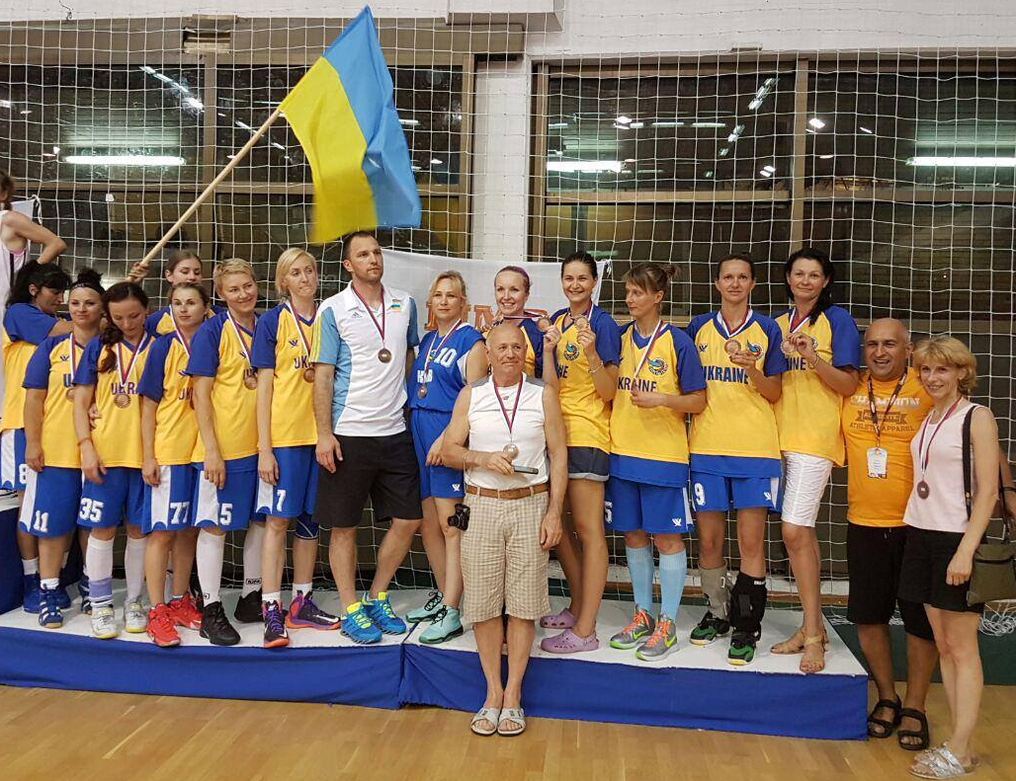
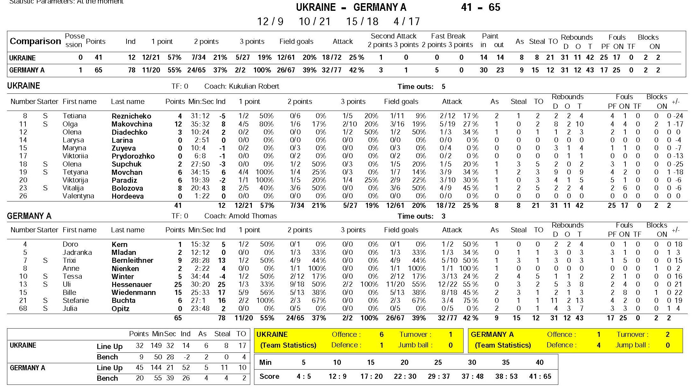
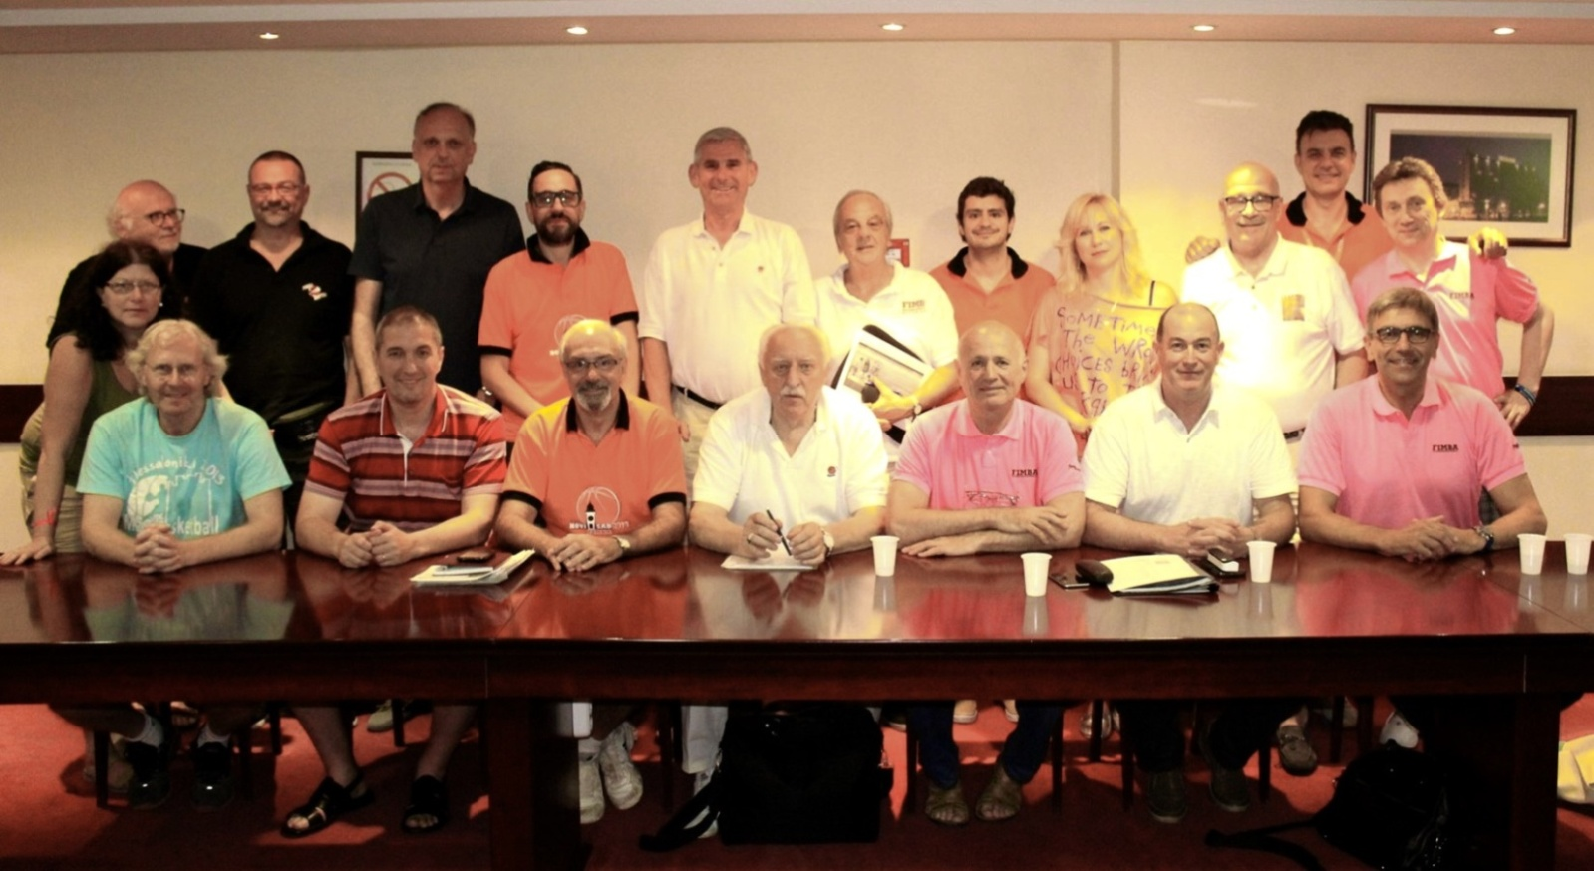
FIMBA representatives in Ukraine Yuriy Zhukov and Elena Zhukovawere honoured to play in the FIMBA GAME match. FIMBA representatives from the different countries were divided into two teams and competed among themselves. The father and daughter Yuriy and Elena Zhukov played in the same team (White) and won the honourable anniversary medals of the Championship.
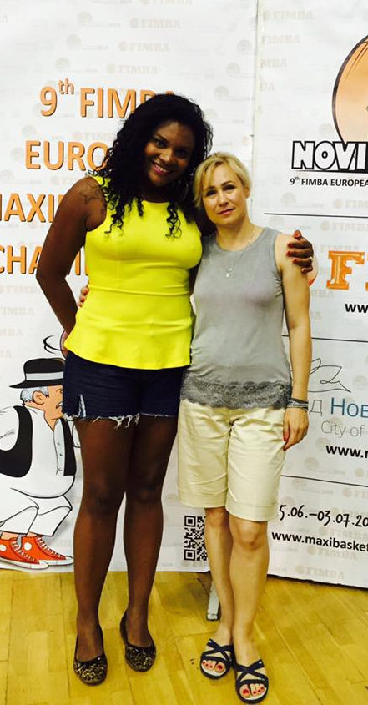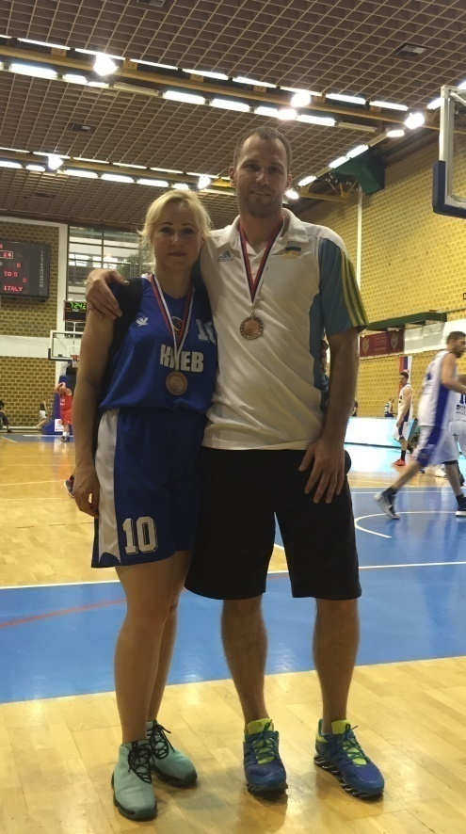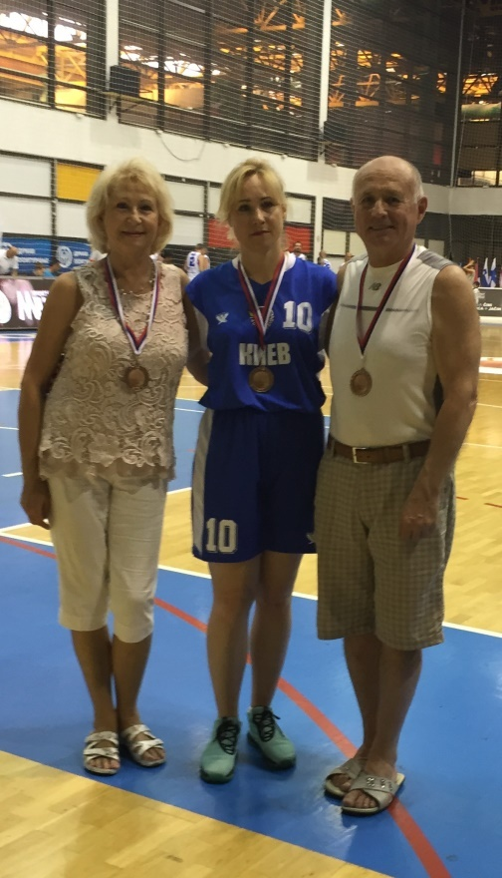

During the Championship FIMBA Europe representatives conference was held in Novi Sad. Elena Zhukova as the member of the FIMBA International Women Committee took part in this meeting. Members of the Women Committee took part in both FIMBA conference, and in work of the committee. Participants of the meeting focused on the development of female and male Maxibasketball movement in Europe considering the challenges facing veterans’ sport. All countries in Europe have the retirement’s problems. All time new veterans’ generations go on well deserved pension with desire to stay longer in good health. And that it what FIMBA can offer through playing Maxibasketball in the second and third age. FIMBA authorities and ordinary Maxibasketball players must be a missionaries to spread the ideas supporting the Maxi movement. AlsoMaxibasketball gives the opportunity to travel and to participate in top-level tournaments. There are an overwhelming amount of scientific evidence on the positive effects of sport and physical activity. Especially in Ukraine physical activity for individuals is a strong mean for prevention of diseases and for nation is a cost-effective method to improve public health across populations. The other main concern is the sports halls. Now in Ukraine and in some other countries it is not too easy to find cities with so many gyms. Especially, with proper playing conditions. FIMBA must work on that side too. Elena Zhukova shared her dream of Sports Hall in Nikolayev with a complex of basketball courts with superb conditions for training and playing matches, and where would take place international tournaments.
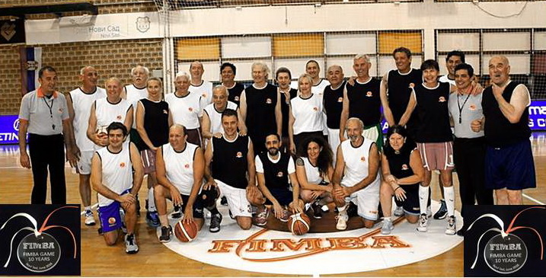
Now Ukrainian Maxibasketball players are waited by the new destination – 14th FIMBA World Maxibasketball Championship 2017 Italy, Tuscany, Montecatini Termi.

